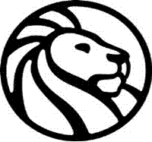
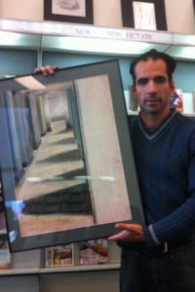
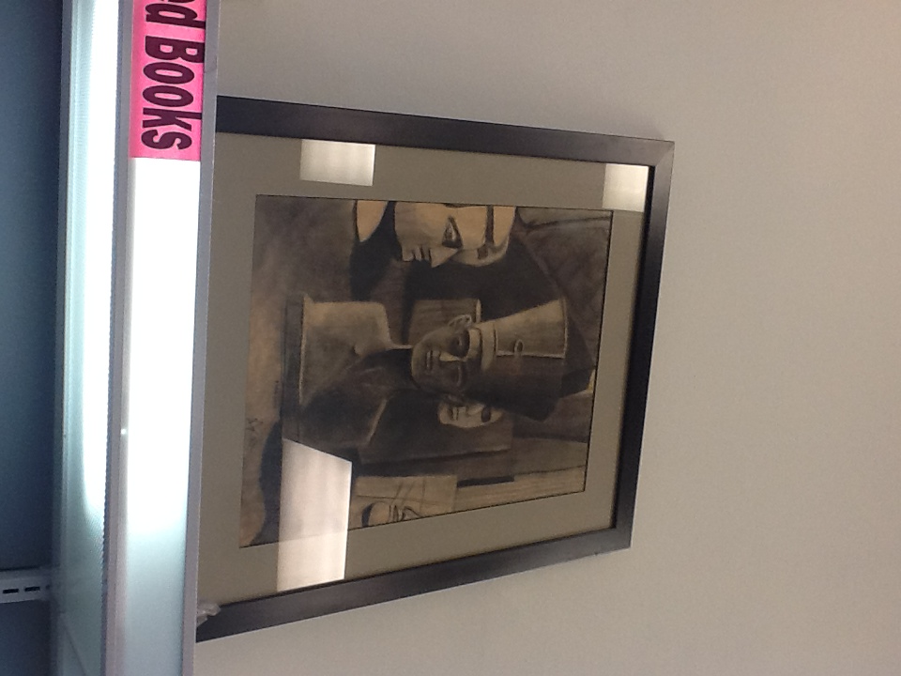

*Edward Patrick Grigg, Artist
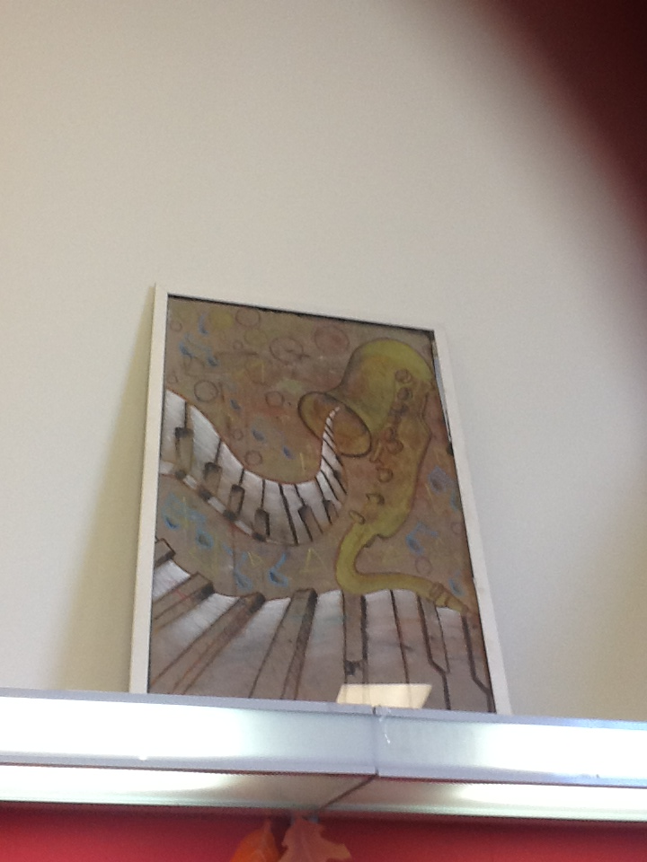
A Native New Yorker, Edward is a 1990 graduate of Art and Design High School; He also graduated with a Bachelor in Fine Arts (1994) from SUNY, New Paltz. An active library patron, Edward Patrick Grigg latest art work is inspired by the library books he enjoyed reading from the New York Public Library since returning from Eastern Europe in January 2012. The Art of Reading is now on display at the Todt Hill – Westerleigh Branch. The various sizes of mixed media, charcoal, pencil and ink are currently on display for public view.
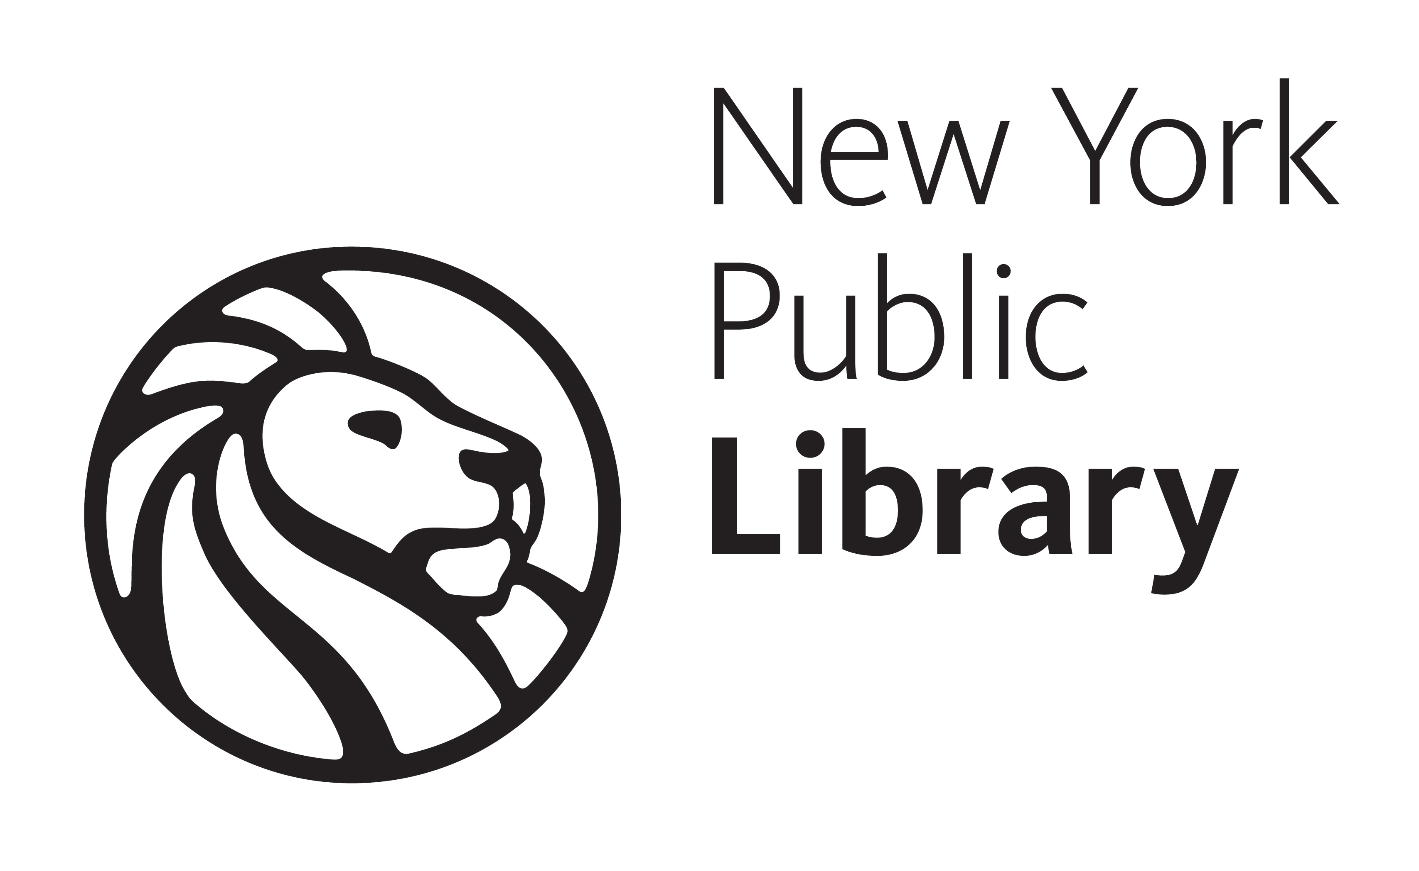
 Fully Accessible

